Partial / residual correlation: GBPUSD and AUDUSD
Method 07 / daily log returns / leave-currency-out USD factor / Alpari D1 full available history

Study setup
Logical pair: GBPUSD , AUDUSD
Broker symbols: GBPUSD_i , AUDUSD_i
Snapshot: 2026-11-03_majors_alpari_D1
Timeframe: D1
Matched return window: 1999-01-05 to 2026-11-02 (UTC bar dates)
Matched return count n: 7148
Dropped unfinished last bar dated 2026-11-03 UTC after a tick-volume check against the prior complete day.
USD-strength sign rule: minus log return when USD is the quote (EURUSD, GBPUSD, AUDUSD, NZDUSD); plus log return when USD is the base (USDJPY, USDCHF, USDCAD). EURGBP is never a constituent.
Control z constituents (5): EURUSD, NZDUSD, USDJPY, USDCHF, USDCAD
z_t = equal-weight mean of those USD-strength returns on the same day
Complete matched rows (Excel): GBPUSD-AUDUSD_Partial_D1.xlsx
Complete matched rows (HTML table): GBPUSD-AUDUSD_Partial_D1_data.html

Method carried forward
Partial / residual correlation regresses each matched daily log return of close, ln(close_t / close_t-1), on the same leave-currency-out USD strength factor z, then takes Pearson correlation of the two residual series. Quotes are not inverted. z is the equal-weight mean of USD-strength returns from other majors that do not share a non-USD currency with either leg; EURGBP is never a constituent. USD-strength is minus the log return when USD is the quote (EURUSD, GBPUSD, AUDUSD, NZDUSD) and plus the log return when USD is the base (USDJPY, USDCHF, USDCAD). OLS uses an intercept on each leg. rho_partial is symmetric under swap of the two symbols. It describes leftover linear co-movement after removing linear z; it is not a cause, not a lead, and not a trading signal. Daily rows are not independent and residuals are estimated, so the two-sided p-value and Fisher interval are secondary. Same-sample raw Pearson r is a side check only.

Regression on z
leg | intercept_a_or_c | slope_b_or_d | R2
GBPUSD | -2.735e-05 | -0.80727669 | 0.41629736
AUDUSD | 2.069e-05 | -1.1821875 | 0.49940379

Results
rho_partial: 0.156705
Two-sided p-value: 1.57247e-40
Approximate 95% Fisher interval: [0.134009, 0.179237]
Same-sample raw Pearson r: 0.540669
rho_partial minus r: -0.383964

Conclusion
Over 7148 matched daily rows for GBPUSD and AUDUSD after removing a leave-currency-out USD factor built from 5 constituents, rho_partial is 0.1567 (positive, weak residual linear link in this sample). Approximate 95% Fisher interval: [0.1340, 0.1792]. Same-sample raw Pearson r is 0.5407 (partial minus r = -0.3840). Leg R-squared on z: GBPUSD=0.4163, AUDUSD=0.4994. Two-sided p under the usual independent-pairs model is 1.572e-40; residuals are estimated and daily FX rows are linked, so treat p as secondary. This does not establish cause, lead-lag, or a lasting trading rule.

Charts
Daily closes
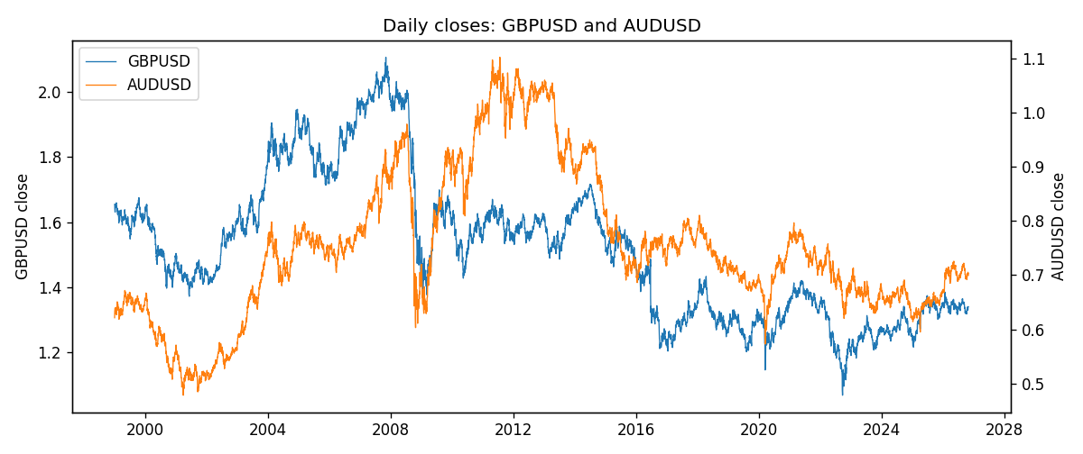
Log returns and control z
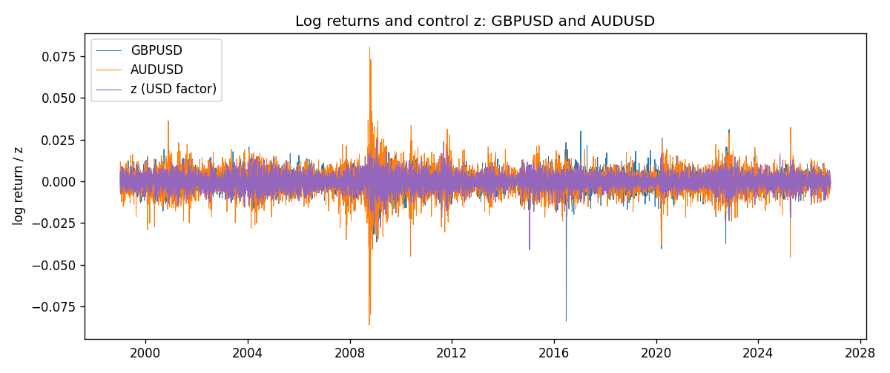
Residual scatter e_x vs e_y
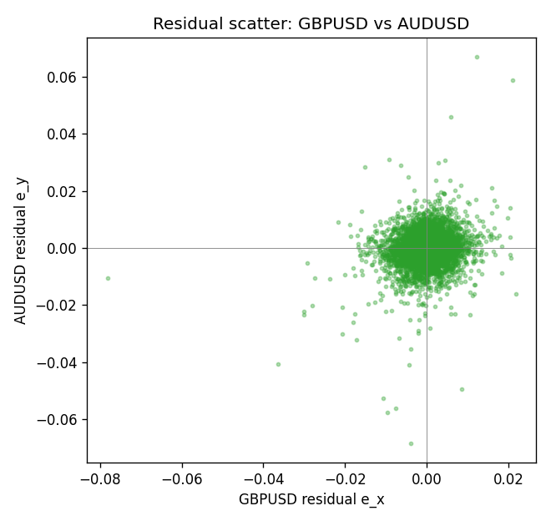

Data report
Every matched row that entered the partial correlation is stored in the sibling Excel workbook named GBPUSD-AUDUSD_Partial_D1.xlsx. That file is the complete data archive for redrawing charts. Embedding all rows as a Word table is impractical at this length; the Word file holds the column list, column summaries, and the first and last 15 matched rows.
Columns: time, GBPUSD_open, AUDUSD_open, GBPUSD_high, AUDUSD_high, GBPUSD_low, AUDUSD_low, GBPUSD_close, AUDUSD_close, GBPUSD_tick_volume, AUDUSD_tick_volume, GBPUSD_spread, AUDUSD_spread, GBPUSD_real_volume, AUDUSD_real_volume, GBPUSD_log_return, AUDUSD_log_return, usd_strength_EURUSD, usd_strength_NZDUSD, usd_strength_USDJPY, usd_strength_USDCHF, usd_strength_USDCAD, z, GBPUSD_fitted, AUDUSD_fitted, GBPUSD_resid, AUDUSD_resid
Column summaries (matched calculation rows)
column | count | mean | std | min | 25% | 50% | 75% | max
GBPUSD_open | 7148 | 1.5147424 | 0.21801364 | 1.06854 | 1.3240425 | 1.50985 | 1.629975 | 2.1066
AUDUSD_open | 7148 | 0.75254463 | 0.13531821 | 0.4785 | 0.661255 | 0.7317 | 0.812135 | 1.10284
GBPUSD_high | 7148 | 1.5210395 | 0.21858109 | 1.08366 | 1.32902 | 1.516685 | 1.6374625 | 2.1161
AUDUSD_high | 7148 | 0.75660194 | 0.1358782 | 0.4878 | 0.6652025 | 0.7351 | 0.8182725 | 1.10795
GBPUSD_low | 7148 | 1.5084277 | 0.21724232 | 1.03518 | 1.3186875 | 1.50192 | 1.6233 | 2.0983
AUDUSD_low | 7148 | 0.74848743 | 0.13462984 | 0.4775 | 0.65803 | 0.727775 | 0.80652 | 1.0975
GBPUSD_close | 7148 | 1.5148153 | 0.21797449 | 1.06879 | 1.324035 | 1.50993 | 1.6299575 | 2.1065
AUDUSD_close | 7148 | 0.75259994 | 0.13529833 | 0.4786 | 0.6614925 | 0.7318 | 0.81193 | 1.10169
GBPUSD_tick_volume | 7148 | 95468.138 | 153933.58 | 62 | 10088.75 | 53396.5 | 92022.25 | 1273370
AUDUSD_tick_volume | 7148 | 77889.255 | 138502.92 | 109 | 5574 | 43696 | 71619 | 1234623
GBPUSD_spread | 7148 | 26.846531 | 19.190643 | 0 | 10.75 | 20 | 50 | 50
AUDUSD_spread | 7148 | 30.707051 | 16.89031 | 0 | 13 | 30 | 50 | 50
GBPUSD_real_volume | 7148 | 3.582457e+09 | 8.4750162e+10 | 0 | 0 | 0 | 0 | 2.4038164e+12
AUDUSD_real_volume | 7148 | 5.2809589e+09 | 1.2584371e+11 | 0 | 0 | 0 | 0 | 3.811512e+12
GBPUSD_log_return | 7148 | -1.992e-05 | 0.00564699 | -0.08388241 | -0.0031217 | 3.426e-05 | 0.00318167 | 0.03112653
AUDUSD_log_return | 7148 | 3.157e-05 | 0.00755018 | -0.08602525 | -0.00385014 | 0.00029168 | 0.00415111 | 0.0806166
usd_strength_EURUSD | 7148 | 2.16e-06 | 0.0058013 | -0.03433183 | -0.00325609 | -0 | 0.00324218 | 0.03123819
usd_strength_NZDUSD | 7148 | -1.914e-05 | 0.00764519 | -0.05966839 | -0.004586 | -0.00023666 | 0.00424201 | 0.07027433
usd_strength_USDJPY | 7148 | 5.267e-05 | 0.00620906 | -0.03908203 | -0.00319392 | 0.00012736 | 0.00340928 | 0.05184024
usd_strength_USDCHF | 7148 | -6.945e-05 | 0.0065937 | -0.19545699 | -0.00334697 | 8.15e-05 | 0.00331954 | 0.09051364
usd_strength_USDCAD | 7148 | -1.226e-05 | 0.00514518 | -0.03859748 | -0.00283513 | 4.873e-05 | 0.00272781 | 0.03436319
z | 7148 | -9.2e-06 | 0.00451333 | -0.04104204 | -0.00254958 | 2.932e-05 | 0.00263718 | 0.02465655
GBPUSD_fitted | 7148 | -1.992e-05 | 0.0036435 | -0.01993201 | -0.00215629 | -5.102e-05 | 0.00203086 | 0.03310493
AUDUSD_fitted | 7148 | 3.157e-05 | 0.0053356 | -0.02912797 | -0.00309695 | -1.397e-05 | 0.00303477 | 0.04854008
GBPUSD_resid | 7148 | 0 | 0.00431433 | -0.07818445 | -0.00213434 | 0.00010961 | 0.00232915 | 0.02178417
AUDUSD_resid | 7148 | 0 | 0.00534196 | -0.06846923 | -0.00241654 | 0.0001607 | 0.00273516 | 0.06708231
First 15 matched rows (selected columns)
time | GBPUSD_close | AUDUSD_close | GBPUSD_log_return | AUDUSD_log_return | z | GBPUSD_fitted | AUDUSD_fitted | GBPUSD_resid | AUDUSD_resid
1999-01-05 | 1.6547 | 0.6215 | -0.0028966287 | -0.00080418179 | 6.5589968e-05 | -8.0299657e-05 | -5.6848094e-05 | -0.002816329 | -0.00074733369
1999-01-06 | 1.6537 | 0.6289 | -0.00060452184 | 0.011836351 | 0.0060686793 | -0.0049264537 | -0.007153625 | 0.0043219319 | 0.018989976
1999-01-07 | 1.6502 | 0.6345 | -0.002118709 | 0.0088650256 | -0.0069288276 | 0.0055661306 | 0.0082118647 | -0.0076848396 | 0.00065316092
1999-01-08 | 1.6405 | 0.6347 | -0.0058954193 | 0.00031515916 | 0.0031351047 | -0.0025582474 | -0.00368559 | -0.0033371719 | 0.0040007491
1999-01-11 | 1.6312 | 0.6393 | -0.0056851331 | 0.0072213815 | -0.0035200037 | 0.0028142665 | 0.0041819958 | -0.0084993997 | 0.0030393856
1999-01-12 | 1.6349 | 0.6362 | 0.0022657001 | -0.0048608485 | 0.0059815304 | -0.0048561005 | -0.0070505987 | 0.0071218006 | 0.0021897503
1999-01-13 | 1.6499 | 0.6312 | 0.0091330396 | -0.0078902098 | -0.0012902969 | 0.0010142762 | 0.0015460644 | 0.0081187634 | -0.0094362742
1999-01-14 | 1.6531 | 0.6295 | 0.0019376331 | -0.002696916 | 0.00093952696 | -0.00078580861 | -0.0010900054 | 0.0027234417 | -0.0016069106
1999-01-15 | 1.6502 | 0.634 | -0.0017558204 | 0.007123101 | 0.005736448 | -0.0046582511 | -0.0067608654 | 0.0029024308 | 0.013883966
1999-01-18 | 1.6522 | 0.6346 | 0.0012112405 | 0.00094592471 | -0.00077610274 | 0.00059917924 | 0.00093819047 | 0.00061206122 | 7.7342387e-06
1999-01-19 | 1.6553 | 0.6392 | 0.0018745281 | 0.0072225153 | -0.00092667312 | 0.0007207312 | 0.0011161929 | 0.0011537969 | 0.0061063224
1999-01-20 | 1.6472 | 0.64 | -0.0049053846 | 0.0012507819 | -0.001002427 | 0.00078188558 | 0.0012057482 | -0.0056872701 | 4.5033672e-05
1999-01-21 | 1.6524 | 0.6405 | 0.0031518998 | 0.00078094498 | -0.0013447157 | 0.0010582072 | 0.0016103976 | 0.0020936926 | -0.00082945262
1999-01-22 | 1.6565 | 0.6327 | 0.0024781662 | -0.012252745 | 0.0043323355 | -0.0035247438 | -0.0051009411 | 0.00600291 | -0.0071518041
1999-01-25 | 1.6585 | 0.6302 | 0.0012066366 | -0.0039591468 | 0.00050533746 | -0.00043529756 | -0.00057671207 | 0.0016419342 | -0.0033824348
Last 15 matched rows (selected columns)
time | GBPUSD_close | AUDUSD_close | GBPUSD_log_return | AUDUSD_log_return | z | GBPUSD_fitted | AUDUSD_fitted | GBPUSD_resid | AUDUSD_resid
2026-10-13 | 1.32534 | 0.69821 | 0.0036434319 | 0.0035007712 | -0.0035002644 | 0.0027983315 | 0.0041586603 | 0.00084510042 | -0.0006578891
2026-10-14 | 1.31884 | 0.69715 | -0.0049164679 | -0.0015193215 | 0.0024043963 | -0.0019683635 | -0.0028217556 | -0.0029481045 | 0.0013024341
2026-10-15 | 1.32757 | 0.69191 | 0.0065976411 | -0.0075447063 | -0.0051233821 | 0.0041086365 | 0.0060774897 | 0.0024890045 | -0.013622196
2026-10-16 | 1.33257 | 0.69426 | 0.0037592051 | 0.0033906408 | -0.002991528 | 0.0023876404 | 0.0035572385 | 0.0013715646 | -0.00016659774
2026-10-19 | 1.33024 | 0.6978 | -0.0017500314 | 0.0050859986 | 0.0011788158 | -0.00097898091 | -0.0013728897 | -0.00077105052 | 0.0064588883
2026-10-20 | 1.3377 | 0.70022 | 0.0055923442 | 0.0034620426 | -0.0029394978 | 0.0023456376 | 0.003495729 | 0.0032467066 | -3.3686323e-05
2026-10-21 | 1.33937 | 0.70275 | 0.0012476328 | 0.0036066384 | -0.0008695786 | 0.00067464013 | 0.0010486965 | 0.00057299271 | 0.0025579419
2026-10-22 | 1.33967 | 0.70186 | 0.00022396082 | -0.0012672558 | -0.0022260297 | 0.0017696715 | 0.002652276 | -0.0015457107 | -0.0039195318
2026-10-23 | 1.33684 | 0.70353 | -0.0021146949 | 0.0023765656 | 0.00085548175 | -0.00071796088 | -0.00099064825 | -0.001396734 | 0.0033672139
2026-10-26 | 1.33359 | 0.70128 | -0.0024340661 | -0.0032032829 | 0.0022383652 | -0.0018343305 | -0.0026254758 | -0.00059973565 | -0.00057780712
2026-10-27 | 1.33044 | 0.70245 | -0.0023648393 | 0.0016669876 | 0.0024659009 | -0.0020180147 | -0.0028944656 | -0.0003468246 | 0.0045614532
2026-10-28 | 1.33254 | 0.70533 | 0.0015771808 | 0.0040915541 | 0.00033863297 | -0.00030072091 | -0.00037963611 | 0.0018779017 | 0.0044711902
2026-10-29 | 1.33733 | 0.70245 | 0.0035881935 | -0.0040915541 | -0.0016483723 | 0.0013033421 | 0.0019693766 | 0.0022848514 | -0.0060609307
2026-10-30 | 1.33913 | 0.70316 | 0.0013450605 | 0.0010102376 | -8.4621628e-05 | 4.0962662e-05 | 0.00012073017 | 0.0013040978 | 0.00088950746
2026-11-02 | 1.3406 | 0.69971 | 0.0010971256 | -0.0049184984 | -0.00068224098 | 0.00052340683 | 0.00082722828 | 0.00057371873 | -0.0057457267

